**A NEW CHANNEL ESTIMATION TECHNIQUE FOR 5G MIMO COMMUNICATION SYSTEMS**

**Abstract:**

One of the key areas where Internet of Things (IoT) is facilitating the use of numerous transmitters on board and enabling the use of Multiple Input Multiple Output (MIMO) systems for improved communications is the health care sector. It can be difficult to use 5G MIMO systems with quality of performance (QoP) that are appropriate for IoT applications. For 5G MIMO wireless communication systems for IoT applications, a training symbol-based channel estimation approach is defined, proposed, and studied in this study. For refining the proposed channel estimator, an M-estimator is recommended. Comparing simulation results with Least Squares (LS) channel estimation with and without Discrete Fourier Transform allows for an evaluation of the suggested technique's performance (DFT).

**Keywords:** ECG Biometric, Authentication.

**Existing Method:**

This method proposed, pilot-assisted techniques for channel estimation (CE) are simulated for Universal Filtered Multi-Carrier (UFMC) modulation scheme. UFMC aims at replacing orthogonal frequency division multiplexing (OFDM) and improves performance and robustness in the case of time frequency misalignment. These techniques efficiently support Internet of Things (IoT) and massive machine type communications (mMTC), which are identified as challenges for 5G wireless communication systems (WCS). Pilot-aided techniques are adopted and applied to OFDM and UFMC. Simulation results are supplemented to compare the performance of UFMC systems with conventional CP-OFDM systems. The flow of the proposed method is shown in figure below:

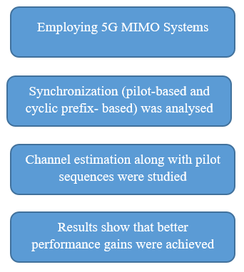

**Fig: Block Diagram of Existing Method**

**Disadvantages:**

* Need more parameters for the implementation.
* Requires high cost.
* Difficult to implement.

**Proposed System:**

In simulations, channel estimation using LS and Proposed M-estimator (with and without DPT) based techniques are compared and shown in Fig. FFT size is 32 and pilot spacing is 4. For improving the performance of channel estimation technique a DFT-method is been developed by suppressing noise effect outside of the maximum channel delay which is shown in simulations. From the simulation results, an observation is done on the proposed method for channel estimation (with and without DFT) as closely approximation of true channel in both the cases.

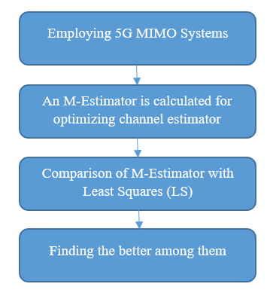

**Fig: Proposed Methodology**

**Advantages:**

* Gives the better results of channel estimation.
* Less complex than the Least Squares (LS) Method.

**Applications:**

There are numerous applications for the use of Biometric Technology, but the most common ones are as follows:

* 5G MIMO
* 5G MISO
* Channel Estimations

**Software & Hardware Requirements:**

**Software Requirements:**

MATLAB R2018a or above

**Hardware Requirements:**

**Operating Systems:**

• Windows 10

• Windows 7 Service Pack 1

• Windows Server 2019

• Windows Server 2016

**Processors:**

Minimum: Any Intel or AMD x86-64 processor

Recommended: Any Intel or AMD x86-64 processor with four logical cores and AVX2 instruction set support.

**Disk:**

Minimum: 2.9 GB of HDD space for MATLAB only, 5-8 GB for a typical installation

Recommended: An SSD is recommended a full installation of all MathWorks products may take up to 29 GB of disk space

**RAM:**

Minimum: 4 GB

Recommended: 8 GB